256 dim 1 layer
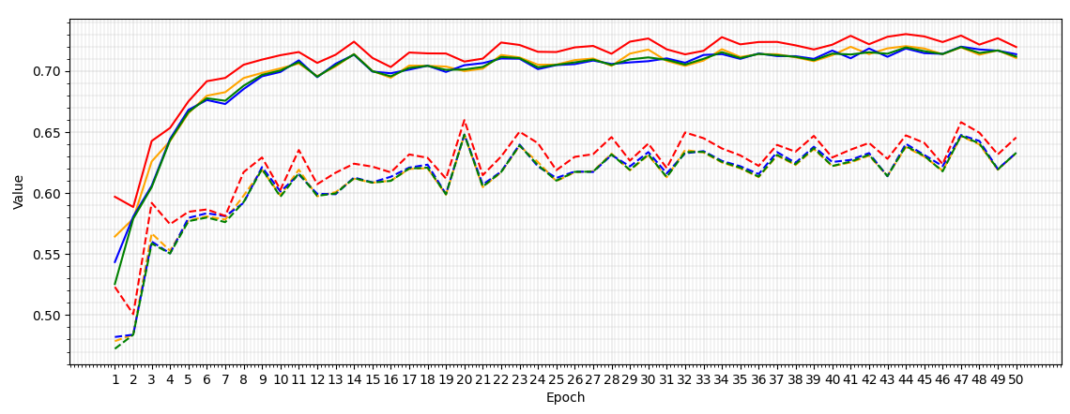
Macro-F1 first above 0.7 at epoch 10
Sample-level - Epoch 47:  Macro-F1: 0.7197  Macro-Precision: 0.7194  Macro-Recall: 0.7200  Accuracy: 0.7291 | Variant-level - Epoch 20:  Macro-F1: 0.6479  Macro-Precision: 0.6478  Macro-Recall: 0.6480  Accuracy: 0.6598
256 dim 2 layers
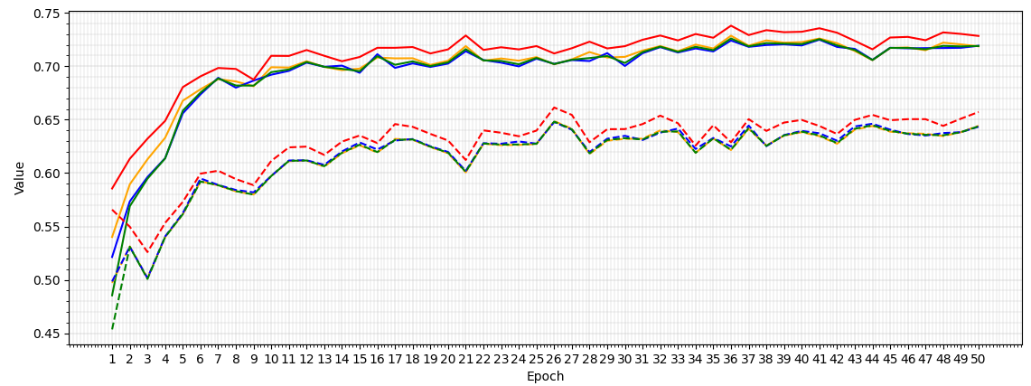
Macro-F1 first above 0.7 at epoch 12
Sample-level - Epoch 36:  Macro-F1: 0.7260  Macro-Precision: 0.7286  Macro-Recall: 0.7241  Accuracy: 0.7380 | Variant-level - Epoch 26:  Macro-F1: 0.6482  Macro-Precision: 0.6487  Macro-Recall: 0.6478  Accuracy: 0.6614
300 dim 1 layer
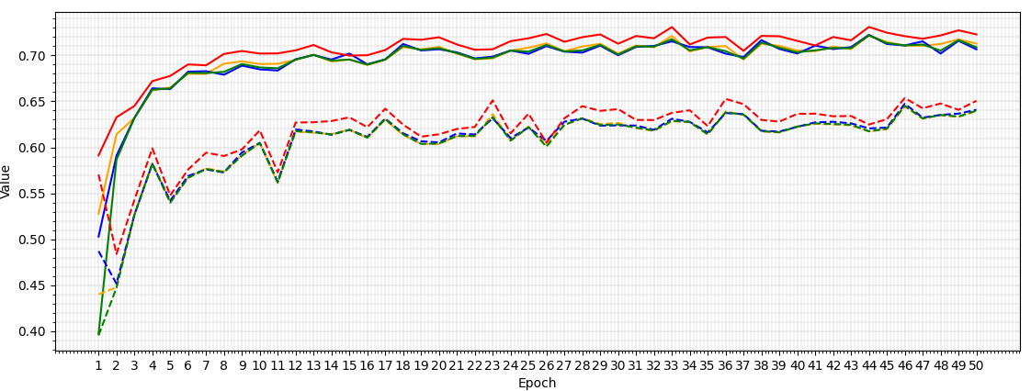
Macro-F1 first above 0.7 at epoch 13
Sample-level - Epoch 44:  Macro-F1: 0.7218  Macro-Precision: 0.7214  Macro-Recall: 0.7223  Accuracy: 0.7309 | Variant-level - Epoch 46:  Macro-F1: 0.6452  Macro-Precision: 0.6444  Macro-Recall: 0.6474  Accuracy: 0.6536
300 dim 2 layers
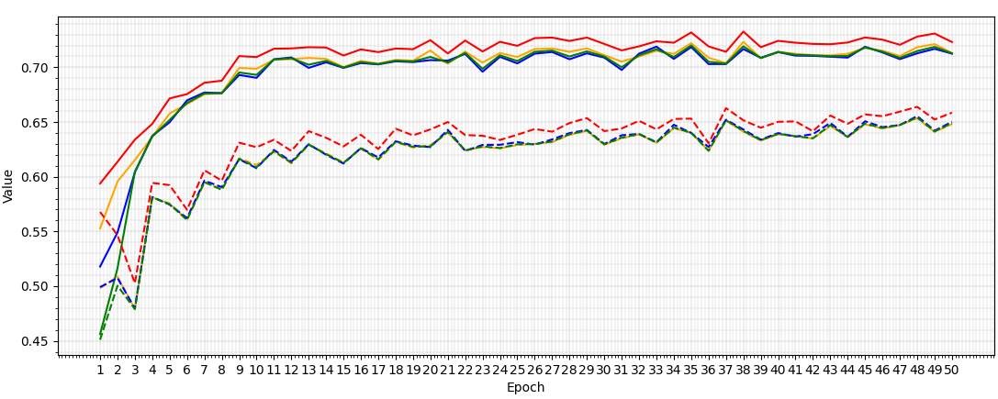
Macro-F1 first above 0.7 at epoch 11
Sample-level - Epoch 35:  Macro-F1: 0.7200  Macro-Precision: 0.7221  Macro-Recall: 0.7185  Accuracy: 0.7319 | Variant-level - Epoch 48:  Macro-F1: 0.6542  Macro-Precision: 0.6534  Macro-Recall: 0.6554  Accuracy: 0.6639
342 dim 1 layer
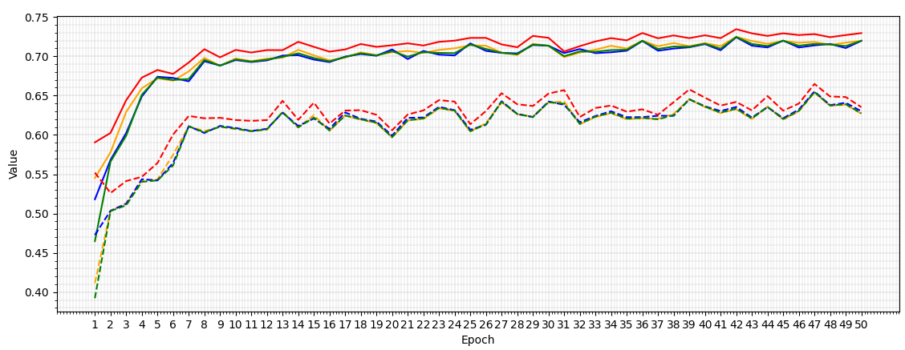
Macro-F1 first above 0.7 at epoch 14
Sample-level - Epoch 42:  Macro-F1: 0.7244  Macro-Precision: 0.7247  Macro-Recall: 0.7241  Accuracy: 0.7344 | Variant-level - Epoch 47:  Macro-F1: 0.6544  Macro-Precision: 0.6538  Macro-Recall: 0.6552  Accuracy: 0.6648
342 dim 2 layers
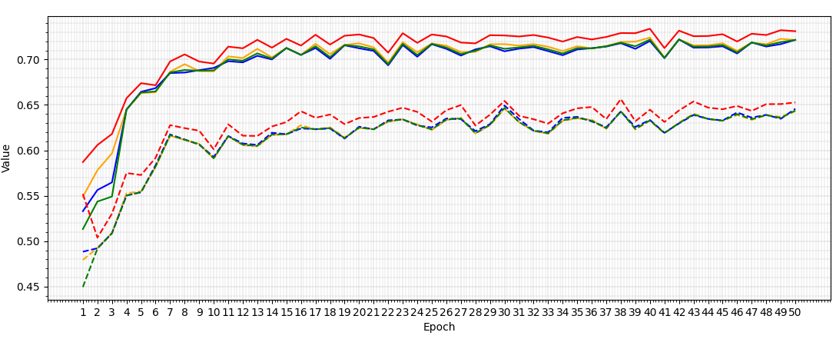
Macro-F1 first above 0.7 at epoch 11
Sample-level - Epoch 42:  Macro-F1: 0.7220  Macro-Precision: 0.7220  Macro-Recall: 0.7220  Accuracy: 0.7317 | Variant-level - Epoch 30:  Macro-F1: 0.6466  Macro-Precision: 0.6459  Macro-Recall: 0.6493  Accuracy: 0.6544
386 dim 1 layer
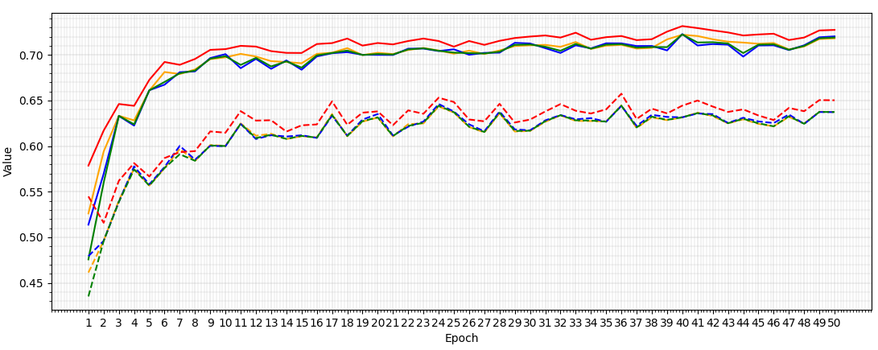
Macro-F1 first above 0.7 at epoch 17
Sample-level - Epoch 40:  Macro-F1: 0.7225  Macro-Precision: 0.7222  Macro-Recall: 0.7229  Accuracy: 0.7317 | Variant-level - Epoch 36:  Macro-F1: 0.6444  Macro-Precision: 0.6447  Macro-Recall: 0.6441  Accuracy: 0.6575
386 dim 2 layers
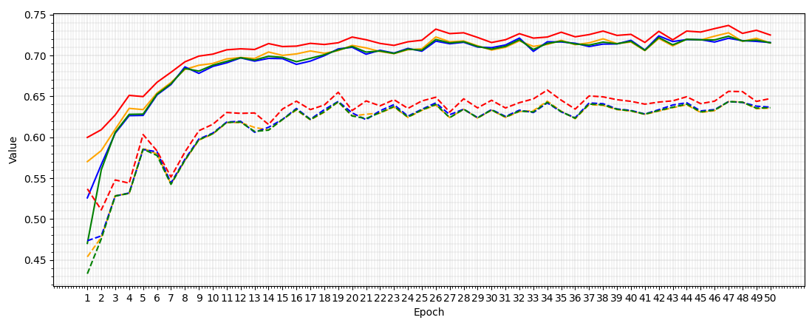
Macro-F1 first above 0.7 at epoch 18
Sample-level - Epoch 47:  Macro-F1: 0.7235  Macro-Precision: 0.7277  Macro-Recall: 0.7210  Accuracy: 0.7367 | Variant-level - Epoch 47:  Macro-F1: 0.6436  Macro-Precision: 0.6436  Macro-Recall: 0.6435  Accuracy: 0.6561

Konklusjon. Denne gangen var maks epoch 50. Å øke til to lag tyder ikke på å gi noen ingen reell betydningen. Halvparten av tilfellene hvor enda et lag ble introdusert, har lavere f1. Den høyeste scoren var på 342 dimensjoner, litt over det av vuldebert på 300.
342 dimensjoner på 1 lag går videre.
500 dims for testing
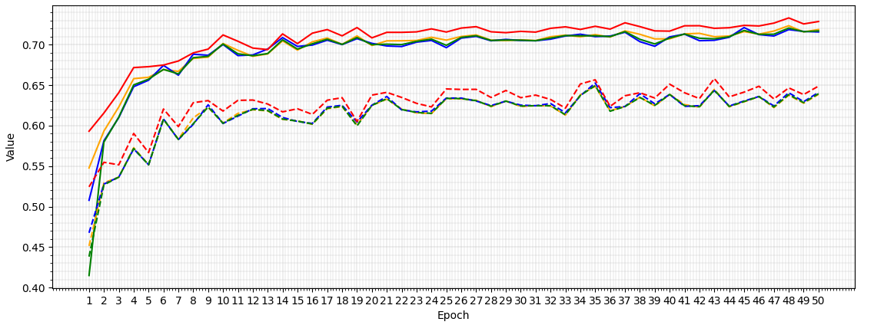
Macro-F1 first above 0.7 at epoch 10
Sample-level - Epoch 48:  Macro-F1: 0.7205  Macro-Precision: 0.7234  Macro-Recall: 0.7186  Accuracy: 0.7330 | Variant-level - Epoch 35:  Macro-F1: 0.6494  Macro-Precision: 0.6487  Macro-Recall: 0.6526  Accuracy: 0.6566

342 dim 1 layer

